**Install Microsoft Message Queue**

Install Microsoft Message Queue by going to Control Panel -> Programs -> Turn Windows features on or off.

Scroll to Microsoft MessageQueue (MSMQ) Server and select it.

**Running Application**

Import Database backpac file available in the repo.

To run the application, Open Terminal and traverse to the WebAPI folder where the “ProducerConsumer.WebAPI.csproj” file is located.

Run the Application by executing the following command in the Terminal ***“dotnet run”***. Open the url shown in the Terminal and add **“/swagger”** at the end

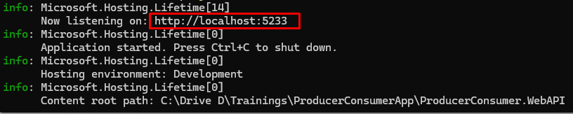

Swagger consists of 2 API Controllers: Producer and Consumer. These both Controller consist of a single Endpoint: ProduceMessage and ConsumeMessage.

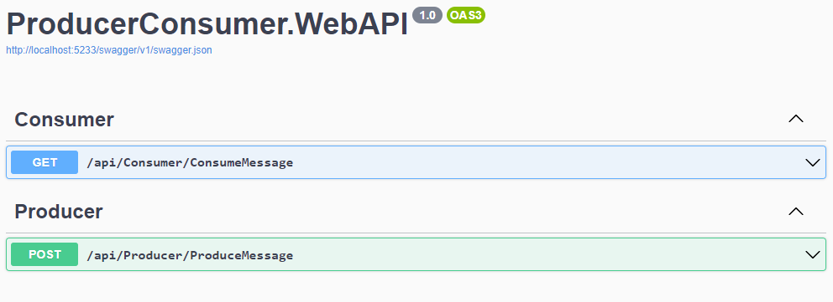

1. **ProduceMessage Endpoint:**

This endpoint is a Post method endpoint with the body containing the message. This message is sent to the message queue and message is also stored in the Database.

The response gives the total no. of unread messages in the queue.

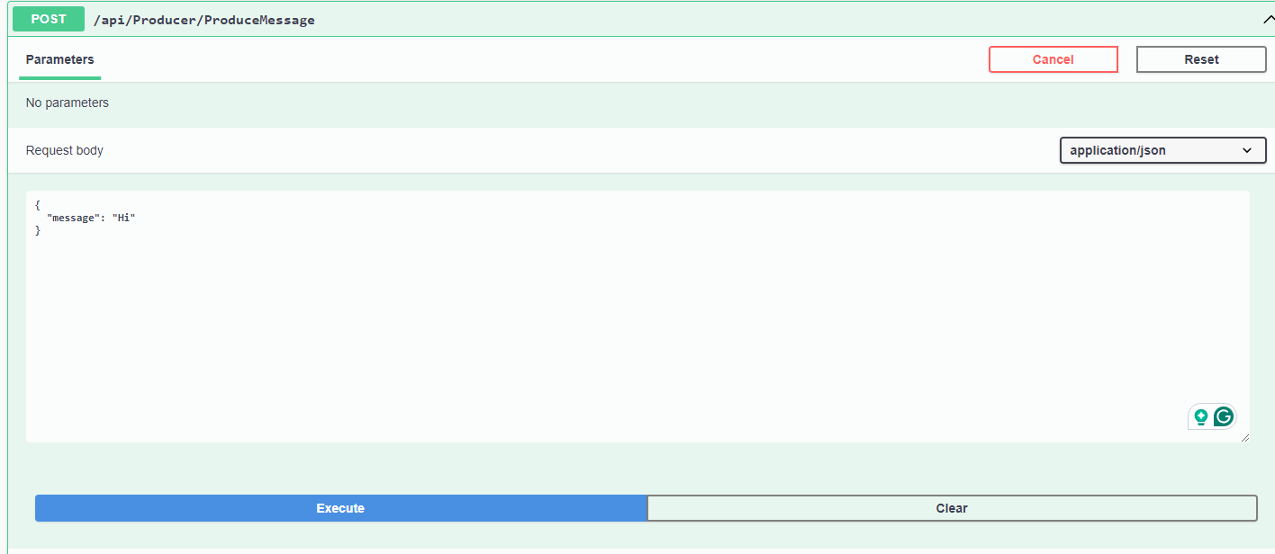

1. **ConsumeMessage Endpoint:**

This endpoint is the Get method endpoint with no parameter. This endpoint reads all the messages in the message queue and processes them.

The response gives the count of successfully processed messages and the count of errors in processing messages.

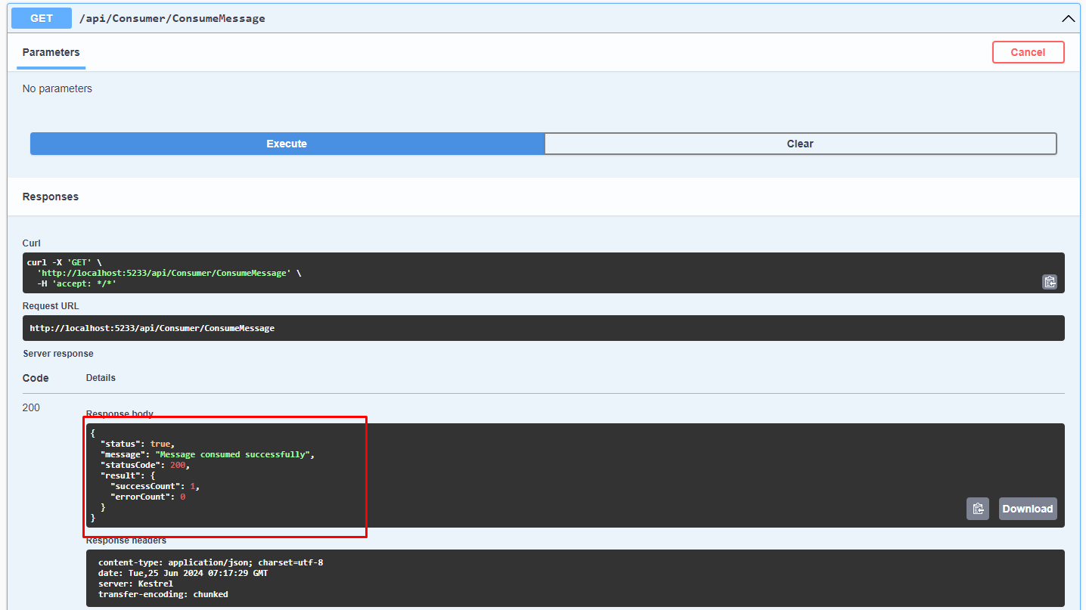

**Running Test Cases**

To run test cases, Open Terminal and traverse to the UnitTests folder where the “ProducerConsumer.UnitTests.csproj” file is located.

Run test cases by executing the following command in the Terminal **“dotnet test”.**

